Nappy, the ingenious

Use-Case Specification: Gamemode 1

Revision History

|  |  |  |  |
| --- | --- | --- | --- |
| **Date** | **Version** | **Description** | **Author** |
| 21/10/2015 | 1.0 | Erstes Version des Dokuments | Mehmet Ali Incekara |
| 23/10/2015 | 1.1 | Add Screenshot | Mehmet Ali Incekara |
| 25/10/2015 | 1.2 | Korrektur Kopfzeile | Mehmet Ali Incekara |
| 29/10/2015 | 1.3 | Gamemode1.feature Screenshot | Mehmet Ali Incekara |
| 13/11/2015 | 1.4 | Remove Cucumber add SikuliX | Mehmet Ali Incekara |
| 21/11/2015 | 1.5 | Translate to English | Mehmet Ali Incekara |
| 30/11/2015 | 1.6 | Update SikuliX | Mehmet Ali Incekara |
|  |  |  |  |
|  |  |  |  |
|  |  |  |  |

Table of Contents

1. Use-Case Gamemode 1 4

1.1 Brief Description 4

2. Flow of Events 5

2.1 Basic Flow 5

2.2 Alternative Flows 8

2.2.1 Abort active game 8

3. Special Requirements 8

4. Preconditions 8

4.1 Game already started 8

5. Postconditions 8

5.1 Game will appear in the statistic 8

5.2 Gamemode 2 or Main screen 8

6. Extension Points 8

Use-Case Specification: Gamemode 1

# Use-Case Gamemode 1

## Brief Description

The Use-Case „Gamemode 1“describes the first of two playable game modes. The user has to think about a character from the Simpsons and the AI (Nappy) is trying to guess the right character.   
Nappy will ask questions and the user can answer them with “Yes”, “No” and “I don’t know”.

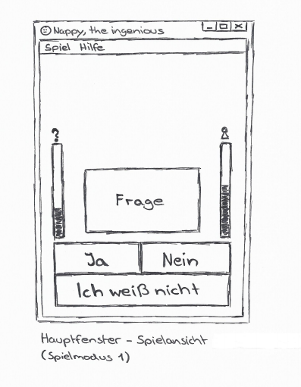

# Flow of Events

## Basic Flow

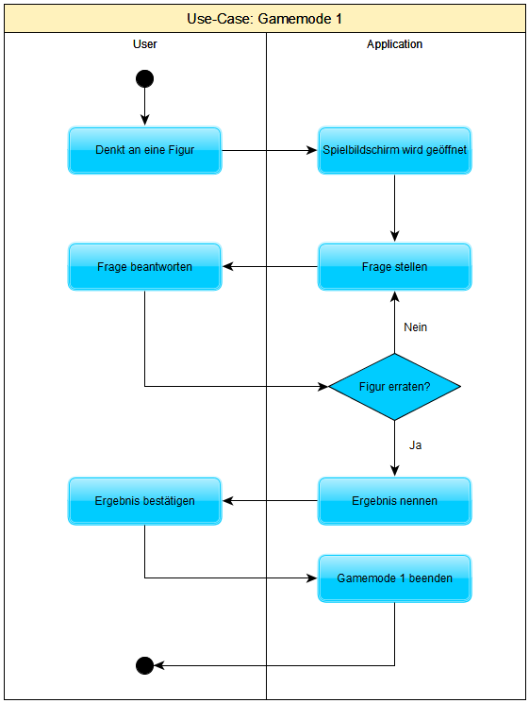

Cucumber is not supported for desktop applications. We are using SikuliX 1.1.0 for our user tests.

Scenario 1: Start game on the main screen

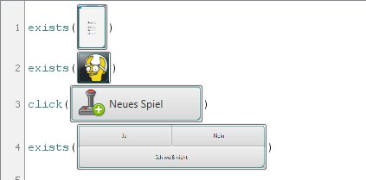

Scenario 2: Start game in the menu

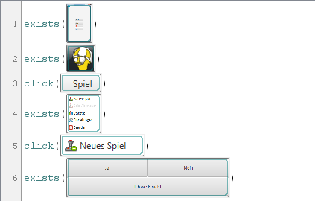

Scenario 3: Abort active game

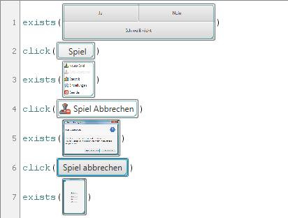

Scenario 4: Play “Gamemode1”

SikuliX-Directory: <https://github.com/nappydevelopment/docs/tree/master/sikulix>

## Alternative Flows

### Abort active game

The user can abort the active game with the function “Abort game” or he can close the application. This game will not appear in the statistics.

# Special Requirements

(n/a)

# Preconditions

## Game already started

The user has to start the game. He can use the button on the main screen or the button in the menu.

# Postconditions

## Game will appear in the statistic

If the user finishes the gamemode 1 then this game will appear in the statistic.

## Gamemode 2 or Main screen

The user can play after the first game mode the second game mode or can skip this.   
If the user skip the second game mode he will forward to the main screen. Otherwise he can play the second game mode.

# Extension Points

(n/a)